**Ali Abdelhamid 222300381**

**AR VR Final Report**

**Screenshots:**

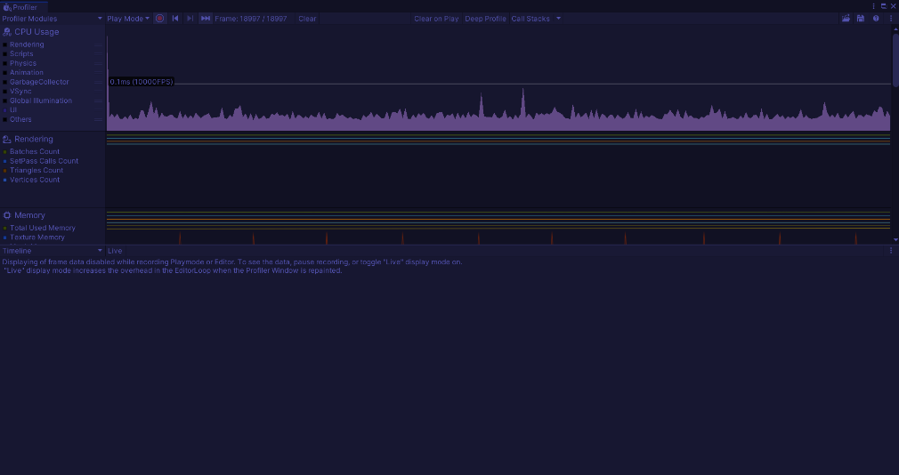

**Optimization Issues:**

As shown in the screenshots above there are spikes in the scripts. This is because I am destroying instances after loading them, this causes a decrease in performance. A solution would be disabling and enabling objects when needed.

I also have text that shows FPS in real-time in the UI, this also causes spikes to happen, dynamic UI causes spikes to happen. A solution would be changing the FPS to the user every couple of seconds, not every time it changes.

The spikes from rendering are most probably because of the loading and changing scenes, it might also be because of the car prefabs. The Dodge prefab has many children inside it, that causes spikes too. To solve this, we can preload the prefabs instead of instantiating them and put them in a pool.

**Design Process:**

My thought process through this project was that I had to include a McLaren car since its my favorite car manufacturer. For the UI I wanted to do everything using buttons that were pictures, because I thought it would be more appealing to the user. I also thought allowing the user to change the colors of the car body and the wheels using a color wheel would be a better user experience because it gives them a very large variety of colors to choose from.